**HOW TO CREATE EFS AND MOUNT THAT ON EC2 LINUX**

Amazon Elastic File System (EFS) provides a simple, server less, scalable, fully managed, elastic NFS file system for use with AWS Cloud services & on-premises resources. Amazon RFS easy to use & offers a simple interface that allows you to create and configure file system quickly & easily.

It is a web serving & content management.

Pre-requisites for mounting the EFS system on your EC2 :-

1. EC2 instance 1
2. EC2 instance 2
3. EFS

If required entities are not present with you, kindly build the same with considering below major points:

1. EC2 1 & EC2 2 should have the same security group.
2. Both instances should have SSH port open for connection.
3. You can have same or different key pair for both the instances.
4. For EFS, name you EFS & select standard so that EFS can be available to multiple availability zones.
5. Mount target is your choice to select to how many availability zone can have the permission.
6. Note :- add the EFS VPC which we selected default to both the EC2 by going to Actions>security>Change security group> add EFS VPC to both the EC2s.

After creating the EC2s & EFS, follow the below steps to link your EFS with EC2s :-

1. Open your machine terminal & change directory where you have saved the .pem file.
2. 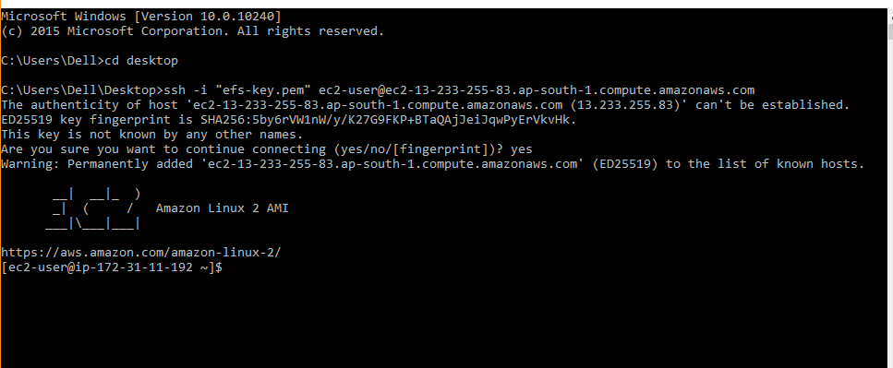Then open the Amazon EC2-1 SSH client & connect through your terminal
3. Please note :- If your SSH port is not working in your terminal then download it from GitHub & change the environment, specify the path in system settings then save.
4. Now install the package :- ***“ sudo yum install -y amazon-efs-utils “***

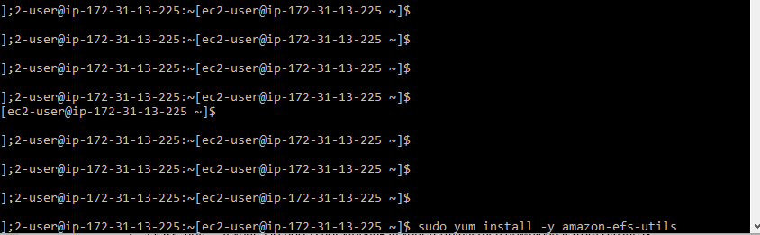

1. Now make a directory by mkdir EFS

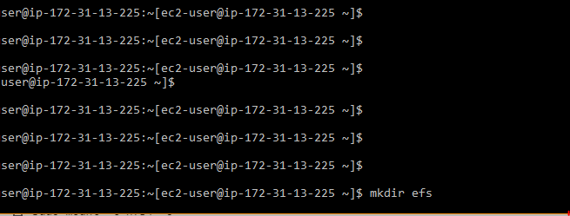

1. Now go to your EFS click on it and then click on attach copy the command Using the EFS mount helper:

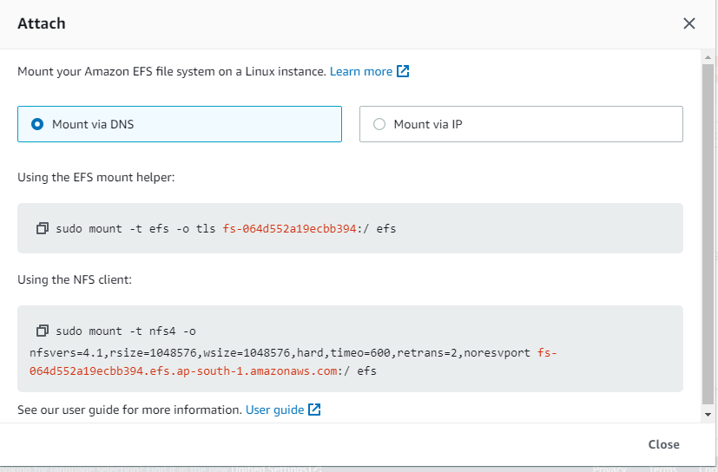

1. Put the command in your amazon terminal and click enter.
2. Now go to the EFS directory by cd command & create some files.
3. Start your second EC2 instance.
4. Again install the utils by following the 4th step.
5. Crate a new directory called EFS & again go to the EFS click attach then again copy the same command and paste in your amazon terminal.
6. Now create some file using touch, nano etc. If not working try Sudo to give root user rights.

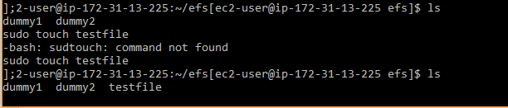

1. Now go to the previous EC2 instance & change directory to efs then use ls command to check weather real time data is syncing or not.

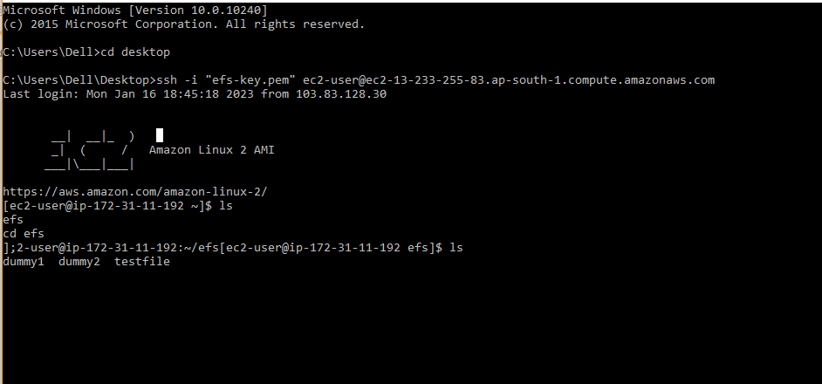

1. Now after everything is completed you can shut down all the services.